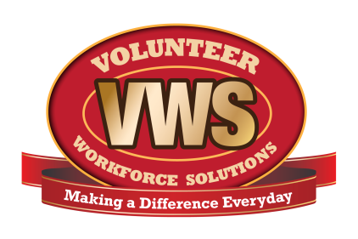
Dept. logo here
Fire Department Name
Address
City, State ZIP Code

Date
Name
Street Address
City, State, ZIP Code

Dear (Name),

We are pleased that you are interested in becoming a member of the (department name) Fire Department. Since (year), members of our community have come forward to volunteer their services to the fire and emergency department. Volunteers have always been true assets to the fire service and the local area. We welcome you to become part of the department’s tradition of nearly (number) years!

Being an effective emergency service provider involves dedication, commitment, training and the desire to help others. Please review all the information in this application packet. Carefully consider the minimum training requirements and the department’s expectations of volunteers before committing. Be sure to think about all your personal obligations as you review this packet. If you feel you will not be able to meet the requirements at this time, state this on the form. We need volunteers in other capacities other than fire and emergency service positions.

We will contact you for an interview once your application and the required paperwork have been received.

If you do not hear from us within two weeks after submitting your completed application, please call (phone number) or email (name), (email address). Leave your name, phone number, and state the reason for your call.

The department appreciates your interest and willingness to become part of the fire service.

Sincerely,

(Signatory Name)
The (department name) Fire Department Recruitment Committee

