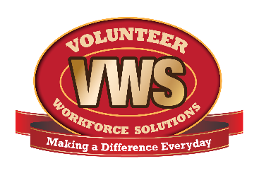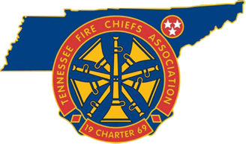
For Immediate Release
January XX, 2018
Contact: Local Contact Name
Local Contact Title
Local Contact phone number
Keep Your Home Warm and Safe This Winter

This is historically the coldest time of the year in many states across the country. Keeping their homes warm is a top priority for most American families. However, with the increased use of numerous alternative heating methods available today comes a marked increase in home fires. Space heaters, wood and coal stoves, and fireplaces all contribute to the increased risk of home fires during winter months.
According to the American Red Cross, home fires are the single most common disaster that they respond to in the United States, with an overwhelming number of them being caused by heating equipment. The National Fire Protection Association (NFPA) states that heating equipment is a leading cause of home fire deaths. December through February are peak times for these type of fires, with half occurring during these three months.
The Tennessee Fire Chiefs Association and Volunteer Workforce Solutions remind families that to keep your family both warm and safe from fire, it is important to make sure you are up-to-date on the latest home heating safety tips. The following tips from NFPA will help reduce the risk of home fire due to heating equipment:
- Keep anything that can burn at least three feet away from heating equipment, like the furnace, fireplace, wood stove, or portable space heater.
- Have a three-foot “kid-free zone” around open fires and space heaters.
- Never use your oven to heat your home.
- Have a qualified professional install stationary space heating equipment, water heaters or central heating equipment according to the local codes and manufacturer’s instructions.
- Have heating equipment and chimneys cleaned and inspected every year by a qualified professional.
- Remember to turn portable heaters off when leaving the room or going to bed.
- Always use the right kind of fuel, specified by the manufacturer, for fuel burning space heaters.
- Make sure the fireplace has a sturdy screen to stop sparks from flying into the room. Ashes should be cool before putting them in a metal container. Keep the container a safe distance away from your home.
- Test smoke alarms at least once a month.
NFPA is an excellent resource for home heating-related educational materials. By accessing the following link, one may take advantage of an educational video about home heating safety, a safety tip sheet, and a community heating safety toolkit designed to create a heating safety campaign in local neighborhoods. Take the time to access these materials and learn how to keep your loved ones warm and safe this winter. http://bit.ly/homeheatingsafety
###
Insert your Department name relies on brave men and women to volunteer their time to serve as volunteer firefighters to ensure that every call for help is answered. Men and women with almost every skill set are needed. To learn more about volunteer opportunities, please contact Insert your Department name at Insert website or call Insert your Dept. phone number.
There are volunteer opportunities at your local volunteer fire department for citizens willing to work hard. To learn more about becoming a volunteer firefighter and joining your local volunteer fire department, please visit www.VolunteerFireTN.org.
About the Tennessee Fire Chiefs Association, Inc. (TFCA)
The TFCA provides leadership to career and volunteer Fire Chiefs, Chief Fire Officers and managers of emergency service organizations throughout the State of Tennessee through vision, information, education, service and representation to enhance their knowledge, skills, and abilities. The TN Fire Chiefs Association (TFCA) also encourages the professional advancement of the fire service to ensure and maintain greater protection of life and property from fire and natural or man-made disasters. The TFCA’s mission is to provide leadership to career and volunteer chiefs, chief fire officers, and managers of Emergency Service Organizations throughout the State of Tennessee through vision, information, education, service and representation to enhance their professionalism and capabilities. More information about the TFCA is located at www.tnfirechiefs.com .
About Volunteer Workforce Solutions (VWS)
The Tennessee Fire Chiefs Association was awarded a SAFER recruitment and retention grant in 2016 and partnered with the International Association of Fire Chiefs to identify recruitment and retention goals, strategies and marketing methodologies that would benefit not only participating departments, but all fire departments in the state. 19 departmental groups, consisting of 64 departments, were selected to participate in Phase I of the program. The VWS program is also operating in Virginia through the Virginia Fire Chiefs Association and Connecticut through the Connecticut Fire Chiefs Association. There is also currently a National VWS effort focusing on diversity and new trainings. More information about the Tennessee VWS can be found at www.VolunteerFireTN.org.
(Insert info about your department in similar format to above)

