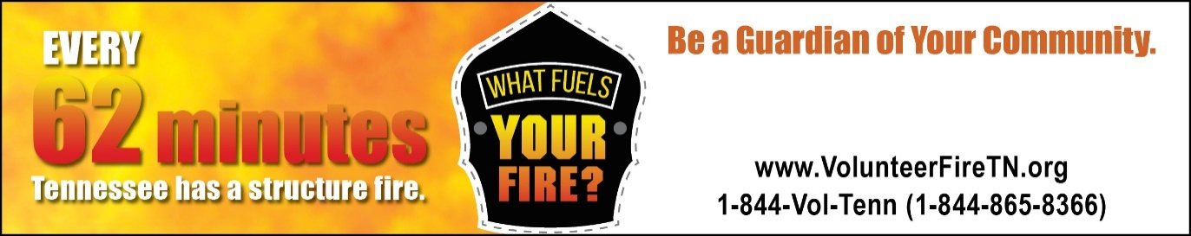

# BE A CITY OF DUNLAP

# VOLUNTEER FIREFIGHTER.