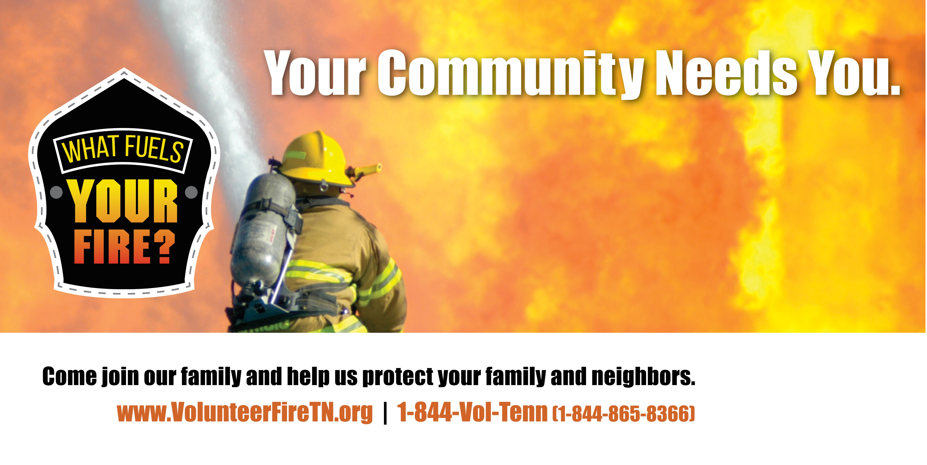

# BE A Your Jurisdiction VOLUNTEER FIREFIGHTER.