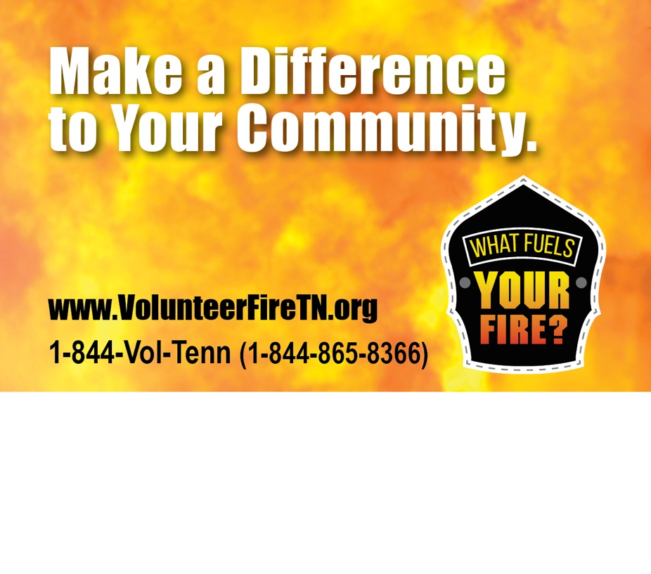

BE A **Your Jurisdiction** VOLUNTEER FIREFIGHTER.

**123 Sample Rd • Sample, TN 12345**

**123-123-1234**

**JOIN Your Jurisdiction**