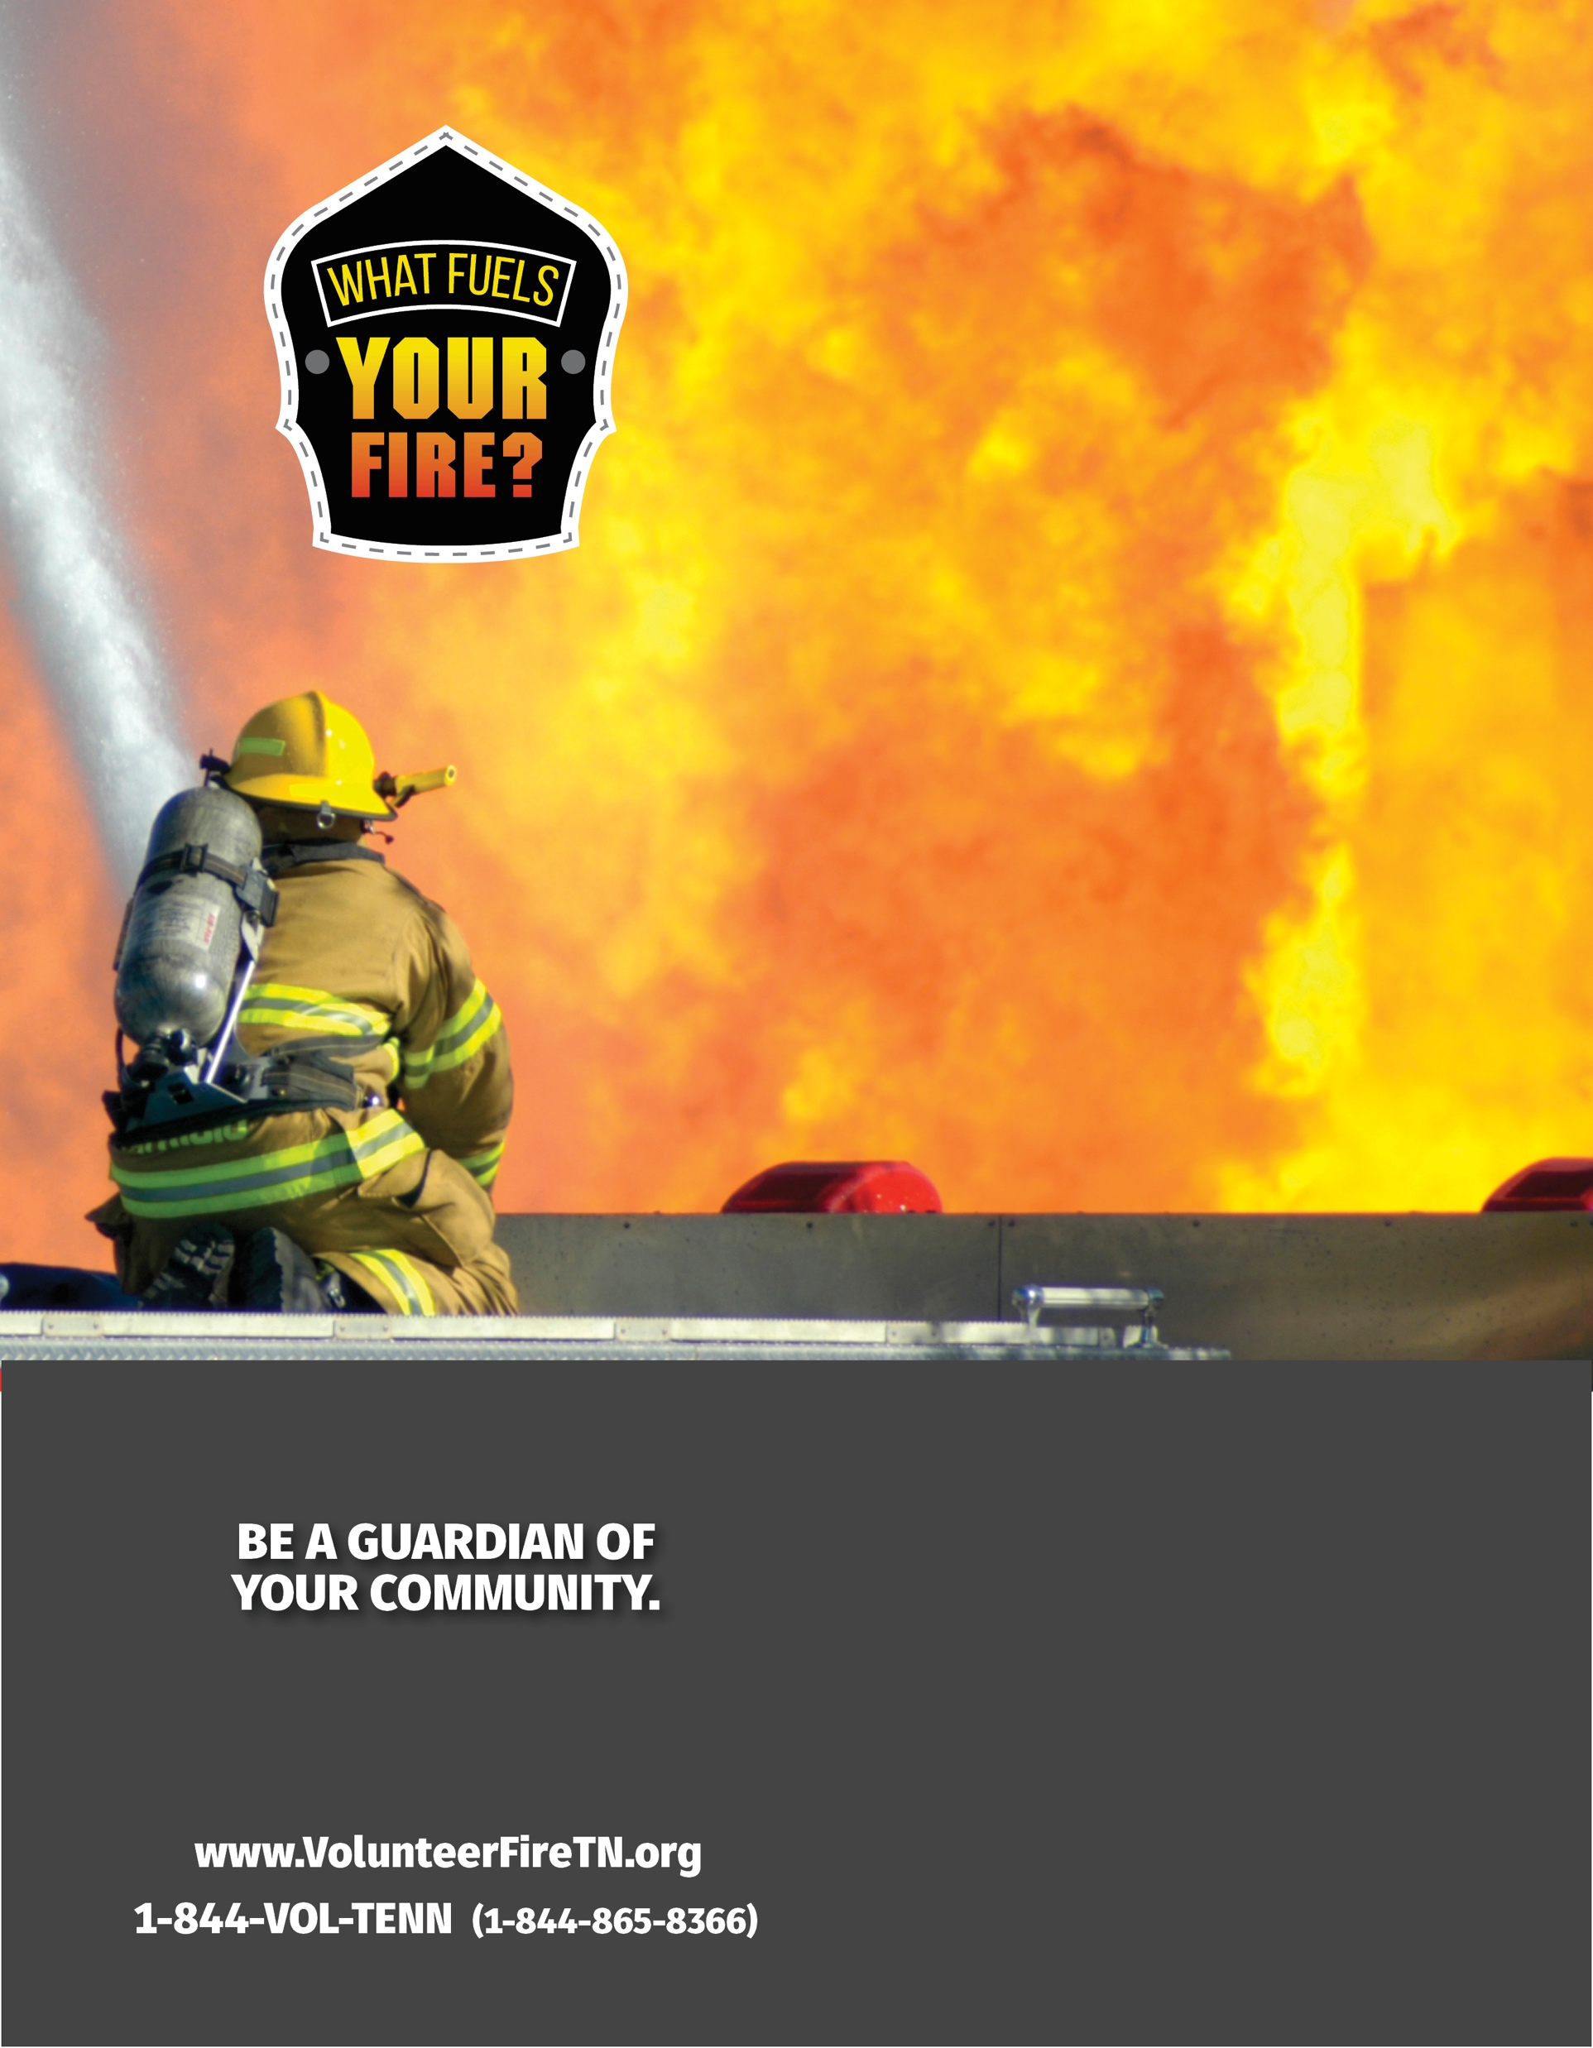

# BE A Your Jurisdiction

# VOLUNTEER FIREFIGHTER